ACMG/AMP Classification Rules Specified for BRCA1 & BRCA2
ENIGMA Variant Curation Expert Panel, Classification Criteria V1.1 2023-11-22.

Overview of documentation supporting specifications

Table 1 summarizes the ACMG/AMP criteria specifications for BRCA1 and BRCA2 variant classification by the Variant Curation Expert Panel (VCEP).
Figure 1 shows the process to apply bioinformatic codes and considerations for incorporating splicing and functional data depending on variant type and position.

The Appendices contain extensive supporting documentation to justify weighting and application of ACMG/AMP codes (Richards et al 2015, PMID: 18414213) for the classification of variants in BRCA1 and BRCA2. Where relevant, specifications and appendices refer to published and unpublished recommendations provided by members of the ClinGen Sequence Variant Interpretation Working Group (SVI). Where possible, code weights were determined from empirical data, and assigned based on “odds of pathogenicity categories” (Table 2), informed from a Bayesian re-analysis of the ACMG/AMP variant classification guidelines (Tavtigian et al 2018, PMID: 29300386), summarized in Appendix A.

Appendix B describes data types previously utilized for BRCA1 and BRCA2 variant classification using a quantitative multifactorial likelihood modeling approach (Goldgar et al 2004, PMID: 15290653; Easton et al 2007, PMID: 17924331; Tavtigian et al 2008, PMID: 8972225; Parsons et al, PMID: 31131967), and categorization according to the IARC 5 tier system (Plon et al, 2008, PMID: 18951446). As appropriate, such likelihood ratio based clinical evidence will be converted to an appropriate ACMG/AMP code weight, and applied under PP4 (combined clinical evidence towards pathogenicity) or BP5 (combined clinical evidence against pathogenicity).

Reference sequences used for annotation are as follows:
BRCA1. Coding DNA reference sequence from genomic refseq NG_005905.2 (same as LRG 292, Ensembl ENSG00000012048) covering BRCA1 transcript NM_007294.4 (Ensembl transcript ENST00000357654.9). Exons are sequentially numbered to match the exon descriptions of the MANE transcript (NM_007294.4). Exon numbering of BRCA1 has historically been according to GenBank U14680.1, with exon 4 missing due to a correction made after the initial description of the gene, termed in this document as legacy exon numbering.
BRCA2. Coding DNA reference sequence from genomic refseq NG_012772.3 (same as LRG 293, Ensembl ENSG00000139618), covering BRCA2 transcript NM_000059.4 (Ensembl transcript ENST00000380152.8).

Appendix C provides an overview of BRCA1 and BRCA2 exon structure (Appendix Figures 1, 2), and a summary of protein functional domains, and their clinical importance (Appendix Tables 3, 4). A clinically important functional protein domain is defined as a recognized protein functional domain reported to harbor one or more clinically important residues. These include BRCA1 RING aa 2-101, BRCA1 BRCT repeats aa 1650-1857, BRCA2 PALB2 binding domain aa 10-40, BRCA2 DNA binding aa 2481-3186. Although no missense variants in the BRCA1 Coiled-Coil domain (aa 1391-1424) are yet considered formally classified as pathogenic, given the suspicion of cancer risk association for at least some missense substitutions in this region, it is termed a potentially clinically important functional domain.

Appendices D to K document additional information of relevance to ACMG/AMP code assignment (as designated in Table 1).

Table 3 and related text denotes the combinations of code strengths required to meet variant classes (benign, likely benign, likely pathogenic, pathogenic).
Note: the proposed classification criteria are set up to differentiate germline high risk variants (associated with cancer risk equivalent to classical pathogenic variants known or predicted to encode a premature termination codon i.e. nonsense or frameshift) from variants with low/no risk. As such, “reduced” penetrance variants associated with moderate risk of cancer may not be reliably distinguished as risk-associated pathogenic variants. e.g. BRCA1 c.5096G>A p.Arg1699Gln (Spurdle et al 2012, PMID: 22889855). Variants with discordances across multiple evidence types will be considered for classification using a points-based approach (see below), and highlighted for further study using approaches aimed at investigating reduced penetrance and/or partial effect on function/splicing.

Table 1: Summary of ACMG-AMP* Criteria Specified for BRCA1 & BRCA2
PATHOGENIC CRITERIA
Criteria |  | Criteria Description |  | Specification  See relevant Appendix for full justification. |  | Relevant tables, figures, links and other information
VERY STRONG CRITERIA
PVS1_VariableWeight |  | Null variant in a gene where loss of function is a known mechanism of disease. |  | In alignment with SVI recommendations for PVS1 code application, evidence strength and description has been separated for different variant types. Apply according to PVS1 flowchart, which considers knowledge of clinically important functional domains. For predicted protein termination codon (PTC) variants, apply with exon-specific weights derived for the PM5 (PTC) code (see description below).  See Appendix D |  | See Table 4, provided as a separate searchable excel file, for a comprehensive summary of codes applicable for all variants considered against the BRCA1 and BRCA2 PVS1 decision trees (initiation, nonsense/frameshift, deletion, duplication, splice site (donor/acceptor ±1,2)) – organized by exon.
PVS1_Variable Weight (RNA) |  | Null variant in a gene where loss of function is a known mechanism of disease, as measured by effect on mRNA transcript profile – mRNA assay only |  | Assay measures effect via mRNA only.  Apply as PVS1_Variable Weight, denoted in summary descriptions as PVS1_Variable Weight (RNA).  See Appendix E |  | See Figure 1B for process to apply codes for splicing data, in content of location and predicted bioinformatic impact of the variant, and adaptive weighting according to assay methodology and proportion of functional transcript retained.
STRONG CRITERIA
PS1_Variable Weight |  | Same amino acid change as a previously established pathogenic variant regardless of nucleotide change.  Also to be applied in the context of splicing predictions. |  | Apply PS1, for predicted missense substitutions, where a previously classified pathogenic variant is considered to act via protein change (no confirmed or predicted effect on mRNA splicing (SpliceAI≤0.1)).  Apply PS1_Moderate, for predicted missense substitutions, where previously established likely pathogenic variant is considered to act via protein change (no confirmed or predicted effect on mRNA splicing (SpliceAI≤0.1)).  Apply PS1_Variable Weight, for exonic and intronic variants with same predicted impact on splicing, as a previously classified (likely) pathogenic variant. Vary weight depending on relative positions, and confidence in classification of the reference variant.  See Appendix E, J, K. |  | For both missense and splicing scenarios, (Likely) Pathogenic variant classification should be assigned using VCEP specifications.  For application of PS1 for splicing predictions, see Table 5. The predicted event of the VUA must precisely match the predicted event of the known (likely) pathogenic variant (e.g. both predicted to lead to exon A skipping, or both to enhanced use of cryptic site B), AND the strength of the prediction for the VUA must be of similar or higher strength than the strength of the prediction for the known (likely) pathogenic variant. For an exonic variant, predicted or proven functional effect of missense substitution/s encoded by the variant and the established pathogenic variant should also be considered before PS1 code application for splicing prediction.
PS2 |  | De novo (paternity confirmed) in a patient with the disease and no family history. |  | Do not use  BRCA1/2-related cancers occur relatively commonly. No information to calibrate the predictive capacity of de novo occurrences.
PS3 – mRNA assay only – Use under alternative code. |  | Well-established in vitro or in vivo functional studies supportive of a damaging effect as measured by effect on mRNA transcript profile – mRNA assay only |  | Assay measures effect via mRNA only.  Apply as PVS1_Variable Weight, denoted in summary descriptions as PVS1_Variable Weight (RNA).  See Appendix E |  | See Figure 1B for process to apply codes for splicing data, in content of location and predicted bioinformatic impact of the variant, and adaptive weighting according to assay methodology and proportion of functional transcript retained.
PS3 - functional assays |  | Well-established in vitro or in vivo functional studies supportive of a damaging effect |  | Assay measures effect via protein only OR mRNA and protein combined.  See Appendix E |  | See Figure 1C for simplified flowchart/s to advise application of codes for functional data, in content of variant type and location within a (potentially) clinically important functional domain.  See Table 9, provided as a separate excel spreadsheet, for a comprehensive table of applicable codes using published calibrated functional assay results.
PS4 |  | The prevalence of the variant in affected individuals is significantly increased compared with the prevalence in controls. |  | Case-control studies; p-value ≤0.05 and OR ≥4 (lower confidence interval excludes 2.0).  See Appendix F |  | Case dataset should be ethnicity and country-matched to control dataset.  If case-control LR estimates are available for a given dataset, these should be used in preference to case-control OR data, under code PP4 (or BP5, if appropriate).
PS4_Moderate |  | Proband Counting: prior observation of the variant in multiple unrelated patients with the same phenotype, and its absence in controls |  | Do not use Proband Counting as originally described.  See Appendix F. |  | Note, personal and family history of cancer may be used as predictors of pathogenicity if derived by clinical calibration, and applied under code PP4 (or BP5, if appropriate).
MODERATE CRITERIA
PM1 |  | Located in a mutational hot spot and/or critical and well-established functional domain. |  | Do not use  Considered as component of bioinformatic analysis (PP3/BP4).
PM2_Supporting |  | Absent/rare from controls in an ethnically-matched cohort population sample. |  | Absent from gnomAD (exome and genome).  See Appendix G  for justification regarding code weight and quality control measures.  Preferred datasets to use:  gnomAD v2.1 non-cancer, exomes  gnomAD v3.1 non-cancer, genomes |  | Observation of a variant only once in a gnomAD outbred population is not informative (no code applied). Do not apply for insertion, deletion or delins variants. Do not apply if read depth <25 at region around the variant.  Exclude data if variant failed quality control filter.
PM3_VariableWeight |  | For recessive disorders, detected in trans with a pathogenic variant. |  | Apply for patient with phenotype consistent with BRCA1- or BRCA2-related Fanconi Anemia (FA), and co-occurrent variants in the same gene.  Phenotype is considered consistent with BRCA1- or BRCA2-related FA if:  (i) Increased chromosome breakage (DEB, MMC, or spontaneous) and at least one clinical feature indicative of BRCA1/2-related FA, categorized under: physical features, pathology and laboratory findings, cancer diagnosis ≤5yr.  (ii) Result unknown for chromosome breakage, and at least two clinical features indicative of BRCA1/2-related FA under at least two of the three categories: physical features, pathology and laboratory findings, cancer diagnosis ≤5yr.  See Appendix H |  | Co-occurrent P or LP variant should be assigned classification using VCEP specifications.  Variant under assessment must be sufficiently rare (meet PM2_Supporting, or PM2 not applicable).  See Table 6 for approach to assign points per proband, and final PM3 code assignment based on the sum of PM3-related points.  For related individuals score only most severe presentation.  Also see Table 6 for additional stipulations
PM4 |  | Protein length changes due to in-frame deletions/insertions in a non-repeat region or stop-loss variants. |  | Do not use  Considered as component of bioinformatic analysis (PP3/BP4).
PM5 |  | Missense change at an amino acid residue where a different missense change determined to be pathogenic has been seen before. |  | Do not use  Considered as component of bioinformatic analysis (PP3/BP4).
PM5_VariableWeight (PTC) |  | Repurposing of PM5 code.  Protein termination codon (PTC) variant in an exon where a different proven pathogenic PTC variant has been seen before |  | Use to justify additional weight for PTC variants annotated as PVS1.  Only applied to genomic PTC changes (not splicing). Weight determined by exon where the termination codon occurs (may not be the same exon as the variant position).  See Appendix D. |  | See Table 4, provided as a separate searchable excel file, for PM5 (PTC) codes applicable for predicted termination codon variants - organized by exon.
PM6 |  | Confirmed de novo without confirmation of paternity and maternity. |  | Do not use  BRCA1/2-related cancers occur relatively commonly. No information to calibrate the predictive capacity of de novo occurrences.
SUPPORTING CRITERIA
PP1_VariableWeight | Co-segregation with disease in multiple affected family members |  | See Appendix I  Apply weight as per Bayes Score:  PP1 - LR >2.08:1  PP1_Moderate – LR>4.3:1  PP1_Strong – LR>18.7:1  PP1_Very Strong – LR>350:1 |  | Recommend use of online tool COOL located on this website:  http://bjfenglab.org/  Additional information, including pedigree formatting, is currently available at:  https://fenglab.chpc.utah.edu/cool3/manual.html  Stipulation: to apply code as Pathogenic Very Strong, VUS should have bioinformatically predicted (or experimentally proven) effect on protein or mRNA splicing. If co-segregation score is from a single family, or several families from an isolated population, assess the possibility of a different causative pathogenic variant.
PP2 | Missense variant in a gene that has a low rate of benign missense variation and where missense variants are a common mechanism of disease. |  | Do not use  High frequency of benign missense variants.
PP3 | Multiple lines of computational evidence support a deleterious effect on the gene or gene product |  | See Appendix J  Apply PP3 for missense or in-frame insertion, deletion or delins variants inside a (potentially) clinically important functional domain and predicted impact via protein change (BayesDel predicted Impact).  Apply PP3 for predicted splicing (SpliceAI ≥0.2) for silent, missense/in-frame (irrespective of location in clinically important functional domain) and for intronic variants outside of the donor and acceptor ±1,2 positions. |  | See Figure 1A for process to apply codes according to variant type, location and predicted bioinformatic impact.  Missense Predictions (BayesDel)  BRCA1:  Impact ≥0.28  BRCA2:  Impact ≥0.30  See footnote** for definition of (potentially) clinically important functional domains.
PP4_Variable Weight | Phenotype specific for disease with single genetic etiology. |  | See Appendix B.  Breast cancer is very common and has a high degree of genetic heterogeneity (caused by pathogenic variants in numerous genes). Use ONLY  to capture combined LR towards pathogenicity, based on multifactorial likelihood clinical data.  PP4 - LR >2.08:1  PP4_Moderate – LR>4.3:1  PP4_Strong – LR>18.7:1  PP4_Very Strong – LR>350:1  Combined LR 1.00-2.08 is not informative (PP4 not applicable). |  | Use in the context of clinically calibrated evidence types, with sufficient detail to review data sources, types and weights.  Published data points may include co-segregation with disease, co-occurrence with a pathogenic variant in the same gene, reported family history, breast tumour pathology, and case-control data. Can also apply for unpublished data, where there is no appropriate ACMG/AMP code. Assign weight based on combined LR for clinical data.  See Table 7 for example applications.
PP5 | Reputable source recently reports variant as pathogenic but the evidence is not available to the laboratory to perform an independent evaluation. |  | Do not use

BENIGN CRITERIA
Criteria | Criteria Description | Specification | Relevant Tables and Figures, text description, caveats
STAND ALONE CRITERIA
BA1 | Stand-alone allele frequency. | Above 0.001 (0.1%)  See Appendix G for justification, including quality control measures.  Preferred datasets to use:  gnomAD v2.1 non-cancer, exomes  gnomAD v3.1 non-cancer, genomes | Apply based on maximum filter allele frequency observed in a gnomAD non-founder population, considering exome and genome data separately.  Do not apply if read depth <20.  Do not apply to well-established pathogenic founder variants.  Exclude data if variant failed quality control filter.
STRONG CRITERIA
BS1,  BS1_Supporting | Allele frequency greater than expected for disease. | BS1 - above 0.0001 (0.01%) BS1_Supporting - >0.00002 (0.002%) to ≤ 0.0001 (0.01%).  See Appendix G for justification, including quality control measures.  Preferred datasets to use:  gnomAD v2.1 non-cancer, exomes  gnomAD v3.1 non-cancer, genomes | Apply based on maximum filter allele frequency in a gnomAD non-founder population, considering exome and genome data separately.  Do not apply if read depth <20.  Do not apply to well-established pathogenic founder variants.  Exclude data if variant failed quality control filter.
BS2_VariableWeight | Observed in a healthy adult individual for a recessive (homozygous), dominant (heterozygous), or X-linked (hemizygous) disorder, with full penetrance expected at an early age | Applied in absence of features of recessive disease, namely Fanconi Anemia phenotype.  See Appendix H | Co-occurrent P or LP variant should be assigned classification using VCEP specifications.  See Table 8 for approach to assign points per proband, and final BS2 code assignment based on the sum of BS2-related points.  Also see Table 8 for additional stipulations.
BS3 – mRNA assay only  Use under alternative code. | Well-established in vitro or in vivo functional studies shows no damaging effect on protein function as measured by effect on mRNA transcript profile – mRNA assay only. | Assay measures effect via mRNA only.  Apply as BP7_Strong (RNA) for intronic, silent, and missense/in-frame variants located outside a (potentially) clinically important functional domain.  See Appendix E. | See Figure 1B for process to apply codes for splicing data, in content of location and predicted bioinformatic impact of the variant, and adaptive weighting according to assay methodology and proportion of functional transcript retained.
For BS3 – functional assays | Well-established in vitro or in vivo functional studies shows no damaging effect on protein function. | Assay measures effect via protein only OR mRNA and protein combined.  See Appendix E. | See Figure 1C for process to apply codes for functional data, in content of variant type and location.  See Table 9, provided as a separate excel spreadsheet, for a comprehensive table of applicable codes using published calibrated functional assay results.  See footnote** for definition of (potentially) clinically important functional domains.
BS4_VariableWeight | Lack of segregation in affected members of a family. | See Appendix I.  Apply weight as per Bayes Score:  BS4_Supporting - LR 0.23-0.48:1  BS4_Moderate - LR <0.23:1  BS4 - LR <0.05:1  BS4_VeryStrong – LR <0.00285:1 | Recommend use of COOL online tool located on this website:  http://bjfenglab.org/  Additional information, including pedigree formatting, is currently available at:  https://fenglab.chpc.utah.edu/cool3/manual.html  Stipulation: To apply code as Benign Very Strong, assess the possibility of bi-linearity to explain negative co-segregation.
SUPPORTING CRITERIA
BP1_Strong | Missense variant in a gene for which primarily truncating variants are known to cause disease | See Appendix J.  Apply BP1_Strong for silent substitution, missense or in-frame insertion, deletion or delins variants outside a (potentially) clinically important functional domain  AND  no splicing predicted (SpliceAI ≤0.1).  Missense prediction not applicable. | See Figure 1A for process to apply codes according to variant type, location and predicted bioinformatic impact.  See footnote** for definition of (potentially) clinically important functional domains.
BP2 | Observed in trans with a pathogenic variant for a fully penetrant dominant gene/disorder, or observed in cis with a pathogenic variant in any inheritance pattern | Do not use  Applied only in the context of BS2.
BP3 | In-frame deletions/insertions in a repetitive region without a known function | Do not use  Captured by bioinformatic tool prediction, and domain analysis.  See Appendix J.
BP4 | Multiple lines of computational evidence suggest no impact on gene or gene product | See Appendix J.  Apply BP4 for:  Missense or in-frame insertion, deletion or delins variants inside a (potentially) clinically important functional domain, and no predicted impact via protein change or splicing (BayesDel predicted No Impact AND SpliceAI ≤0.1).  Silent variant inside a (potentially) clinically important functional domain, if no predicted impact via splicing (SpliceAI ≤0.1).  Intronic variants outside of the  donor and acceptor ±1,2 positions  AND no predicted impact via splicing (SpliceAI ≤0.1). | See Figure 1A for process to apply codes according to variant type, location and predicted bioinformatic impact.  Missense Predictions (BayesDel)  BRCA1:  No impact ≤ 0.15  BRCA2:  No impact ≤ 0.18  See footnote** for definition of (potentially) clinically important functional domains.
BP5 | Variant found in a case with an alternate molecular basis for disease | See Appendix B and Appendix K for justification.  N/A for co-observation: cases with pathogenic variants in two (or more) different known breast–ovarian cancer risk genes have no specific phenotype.  Use ONLY to capture combined LR against pathogenicity, based on multifactorial likelihood clinical data.  BP5_VeryStrong – LR <0.00285:1  BP5_Strong - LR <0.05:1  BP5_Moderate - LR <0.23:1  BP5 - LR 0.23-0.48:1  Combined LR 0.48-1.00 is not informative (BP5 not applicable) | Use in the context of clinically calibrated evidence types, with sufficient detail to review data sources, types and weights. Published data points may include co-segregation with disease, co-occurrence with a pathogenic variant in the same gene, reported family history, breast tumour pathology, and case-control data. Can also apply for unpublished data, where there is no appropriate ACMG/AMP code. Assign weight based on combined LR for clinical data.  See Table 7 for example applications
BP6 | Reputable source recently reports variant as benign but the evidence is not available to the laboratory to perform an independent evaluation | Do not use
BP7 | A synonymous (silent) variant for which splicing prediction algorithms predict neither an impact to the splice consensus sequence nor the creation of a new splice site AND the nucleotide is not highly conserved. | See Appendix J.  Apply BP7 for  Silent variant inside a (potentially) clinically important functional domain, IF BP4 met.  Intronic variants located outside conserved donor or acceptor motif positions  (at or beyond positions +7/-21)  IF BP4 met | Following convention, this code is applied in addition to BP4 (no splicing prediction, Splice AI ≤0.1) to capture the low prior probability of pathogenicity of silent variants.  Nucleotide conservation is not considered relevant.  See Figure 1A for process to apply codes according to variant type, location and predicted bioinformatic impact.  See footnote** for definition of (potentially) clinically important functional domains.
BP7_Strong (RNA) | Re-purposing of BP7 code.  Well-established in vitro or in vivo functional studies shows no damaging effect on protein function as measured by effect on mRNA transcript profile – mRNA assay only. | Assay measures effect via mRNA only.  Apply as BP7_Strong (RNA) for intronic, silent, and missense/in-frame variants located outside a (potentially) clinically important functional domain.  See Appendix E. | See Figure 1B for process to apply codes for splicing data, in content of location and predicted bioinformatic impact of the variant, and adaptive weighting according to assay methodology and proportion of functional transcript retained.
* Original ACMG criteria codes and descriptions are as per Richards et al 2008 (PMID: 18414213).
** As justified in the appendices, (potentially) clinically important functional domains are defined as: BRCA1 RING aa 2-101; BRCA1 coiled-coil aa 1391-1424; BRCA1 BRCT repeats aa 1650-1857; BRCA2 PALB2 binding domain aa 10-40; BRCA2 DNA binding aa 2481-3186.

Table 2: Pathogenic and Benign code strength assignment based on measured odds in favour of pathogenicity*
Code Strength | Odds range for Pathogenic codes | Odds range for Benign Codes
Strong | >18.70 to 350 | <0.05 to 0.00285
Moderate | >4.30 to 18.70 | <0.23 to 0.05
Supporting | >2.08 to 4.30 | <0.48 to 0.23
No evidence | 1.00 to 2.08 | 0.48 to 1.00
*LR ranges proposed as consistent with ACMG/AMP qualitative rule strengths (Tavtigian et al., 2018, PMID: 29300386).

Combination of evidence types for different class tiers

We propose to compare two approaches to combining evidence types.

The first approach, to be applied as default, represents a minor adaptation of the traditional ACMG-AMP classification system (PMID: 18414213), incorporating results from the Bayesian Framework analysis of Tavtigian et al 2018 (PMID: 29300386); criteria will be combined to reach different classes as shown in Table 2.

Table 3: RULES FOR COMBINING CRITERIA following adapted ACMG-AMP approach

Pathogenic | Uncertain Significance | Benign
1 Very strong AND  - ≥1 Strong OR  - ≥1 Moderate OR  - ≥2 Supporting | Other criteria shown in this table are not met | 1 Stand-alone
1 Strong AND  - ≥3 Moderate OR  - 2 Moderate & ≥2 Supporting OR  - 1 Moderate & ≥4 Supporting | The criteria for benign and pathogenic are contradictory, and cannot be resolved using a point-based approach (see below). | 1 Very Strong AND  - 1 Strong OR  - 1 Moderate OR  - 1 Supporting
 |  | ≥2 Strong
2 Strong AND  - ≥1 Moderate OR  - ≥2 Supporting |  | 1 Strong AND  - 2 Moderate OR  - 1 Moderate & ≥1 Supporting OR  - ≥3 Supporting
≥3 Strong
Likely pathogenic |  | Likely Benign
1 Very strong AND 1 Supporting |  | 1 Strong AND  - 1 Supporting OR  - 1 Moderate
2 Strong |  | 1 Moderate AND 1 Supporting
1 Strong AND 1–2 Moderate |  | 1 Moderate AND 1 Supporting
1 Strong AND ≥2 Supporting |  | ≥2 Supporting
≥3 Moderate |  | ≥2 Supporting
2 Moderate AND ≥2 Supporting |  | 1 Strong, if based on multiple evidence types*
1 Moderate AND ≥4 Supporting |  | 1 Strong, if based on multiple evidence types*
* Likely Benign can be assigned based on one Strong Benign code if multiple evidence types contribute to the code assigned. For example: BS4, if multiple likelihood ratios contribute to the combined likelihood ratio used to assign strong evidence; BP1_Strong represents a combination of the following evidence types: variant type, position (domain info) and prediction (splicing).

The second approach, to be applied when both benign and pathogenic criteria are met, is the point system recently proposed to simplify scoring and class assignment (Tavtigian et al 2020, PMID: 32720330). Contradictory evidence includes uninformative bioinformatic evidence, PP3 and BP4 not assigned. Point values assigned for the different code strengths were as recommended in the original publication: Indeterminate=0; Supporting=1, Moderate=2, Strong=4 and Very Strong=8 for Pathogenic codes; negative values for Benign codes of same strength. Point ranges to assign class will follow the conservative recommendations in the original publication: Benign ≤-7, Likely Benign -6 to -2, Uncertain -1 to 5, Likely Pathogenic 6-9, Pathogenic ≥10.

Note: both of these approaches assume a global prior probability of pathogenicity of 0.10. On this basis, any evidence type reaching 1000:1 odds against pathogenicity is sufficient to classify a variant as stand-alone Benign, while evidence with combined odds of 350:1 against (equivalent to lower bound of Very Strong Benign evidence) is sufficient to classify a variant as Likely Benign.

Tables and Figures with additional information for lookups

Table 4: Summary of codes applicable for variants considered against the BRCA1 and BRCA2 PVS1 decision trees.
This Table is provided as a separate file in excel format to facilitate searches and look-ups by variant c. nomenclature, exon etc.
It includes PVS1 and PM5 codes recommended for initiation, nonsense/frameshift, deletion, duplication and splice site (donor/acceptor ±1,2) variants– organized by exon. Full gene deletion is not included as this is considered as Stand Alone evidence for pathogenicity.

Table 5: PS1 code weights for variants with the same predicted splicing event as a known (likely) pathogenic variant*

Variant Under Assessment (VUA) | Baseline computational/predictive code applicable to VUA | Position of reference variant compared to VUA | PS1 code applicable to VUA
Variant Under Assessment (VUA) | Baseline computational/predictive code applicable to VUA | Position of reference variant compared to VUA | with P reference variant | with LP reference variant
Located outside donor/acceptor  ±1,2 dinucleotide positions | PP3 | Same nucleotide | PS1 | PS1_Moderate
Located outside donor/acceptor  ±1,2 dinucleotide positions | PP3 | Within same donor/acceptor motif (including at ±1,2 positions) | PS1_Moderate | PS1_Supporting
Located at donor/acceptor  ±1,2 dinucleotide positions | PVS1 | Within the same donor/acceptor dinucleotide | PS1_Supporting | N/A
Located at donor/acceptor  ±1,2 dinucleotide positions | PVS1 | Within same donor/acceptor motif, but outside dinucleotide# | PS1_Supporting | PS1_Supporting
Located at donor/acceptor  ±1,2 dinucleotide positions | PVS1_Strong, PVS1_Moderate, or PVS1_Supporting | Within the same donor/acceptor dinucleotide | PS1 | N/A
Located at donor/acceptor  ±1,2 dinucleotide positions | PVS1_Strong, PVS1_Moderate, or PVS1_Supporting | Within same donor/acceptor motif, but outside dinucleotide# | PS1_Moderate | PS1_Supporting
* Prerequisite for all: The predicted event of the VUA must precisely match the predicted event of the known (likely) pathogenic variant (e.g. both predicted to lead to exon A skipping, or both to enhanced use of cryptic site B), AND the strength of the prediction for the VUA must be of similar or higher strength than the strength of the prediction for the known (likely) pathogenic variant. (Likely) pathogenic variant should be assigned classification using VCEP specifications. For an exonic variant, predicted or proven functional effect of missense substitution/s encoded by the VUA and (likely) pathogenic variant should also be considered before application of this code. Donor/acceptor dinucleotide positions refer to donor and acceptor ±1,2 dinucleotides in reference transcript/s used for curation. Designated donor and acceptor motif ranges should be based on position weight matrices for intron category. For GT-AG introns these are defined as follows: the donor site motif, last 3 bases of the exon and 6 nucleotides of intronic sequence adjacent to the exon; acceptor site motif, first base of the exon and 20 nucleotides upstream from the exon boundary. Consider other motif ranges for non GT-AG introns.
# If relevant, splicing data for a pathogenic variant outside the donor/acceptor ±1,2 dinucleotide positions may be used to update a PVS1 decision tree, and hence the applicable PVS1 code for a donor/acceptor dinucleotide variant.

Table 6: PM3-related points assigned to an individual with co-occurrent variants and FA phenotype:
Presentation of proband with variant under assessment* | Points per BRCA1-related (FANCS) or BRCA2–related (FANCD1) Fanconi Anemia patient
Presentation of proband with variant under assessment* | P or LP in trans or homozygote** | Phase unknown
Phenotype consistent with BRCA1- or BRCA2-related FA*** | 2 | 1
* Variant under assessment must be sufficiently rare (meet PM2_Supporting, or PM2 not applicable). Consider other gene panel test results as potential explanation for phenotype.
** Co-occurrent P or LP variant should be assigned classification using VCEP specifications. Stipulation for in trans can be met by genotyping of at least one parent, or assumed if VUA is seen with at least 2 different P/LP variants. Further, co-occurrence in trans can be inferred in the case of a homozygote FA-affected patient due to a consanguineous union, or if both maternal and paternal lineages present with family history of cancer consistent with BRCA1 or BRCA2 related cancers.
**phenotype considered to be consistent with BRCA1- or BRCA2-related FA if features meet (i) or (ii) below:
- Increased chromosome breakage and radial forms on cytogenetic testing of lymphocytes with diepoxybutane (DEB) and/or mitomycin C (MMC) or evidence of spontaneous chromosome breakage, plus at least one clinical feature indicative of BRCA1/2-related FA that is encapsulated under one of the three categories below: Physical features, Pathology and laboratory findings, Cancer diagnosis ≤5yr.
- Result unknown for DEB/MMC chromosome breakage test or spontaneous chromosome breakage, and at least two clinical features indicative of BRCA1/2-related FA that are encapsulated under at least two of the three categories below: Physical features, Pathology and laboratory findings, Cancer diagnosis ≤5yr.
  - FA Physical features (in ~75% of affected persons), include: prenatal and/or postnatal short stature; abnormal skin pigmentation (e.g., café au lait macules, hypo-pigmentation); Skeletal malformations (e.g., hypoplastic thumb, hypoplastic radius); Microcephaly, triangular face; Ophthalmic anomalies; Genitourinary tract anomalies. See Orphanet (https://www.orpha.net/consor/cgi-bin/Disease_HPOTerms_Simple.php?lng=EN) for full list of >100 HPO terms (and their reported frequency).
  - FA Pathology and laboratory findings (non-cancer related) include: inordinate toxicities from chemotherapy or radiation, and also progressive bone marrow failure (unrelated to cancer treatment), aplastic anemia, myelodysplastic syndrome, macrocytosis, cytopenia (especially thrombocytopenia, leukopenia, and neutropenia), and increased fetal haemoglobin (often precedes anemia).
  - Cancer diagnosis ≤5yr.

Assign final PM3 code based on sum of PM3-related points from observations across multiple unrelated individuals, as follows:
PM3_Strong = 4 (or more) points; PM3 = 2 points; PM3_Supporting = 1 point.

Table 7: Example application of PP4 and BP5 codes based on multifactorial likelihood clinical data points
Example Variant | Previously Published | Source(s) | Co-Segregation LR | Tumour Pathology LR | Co-occurrence LR | Family History LR | Combined Clinical LR for PP4 or BP5 ª | Code/s to apply | Text Description
1 | Yes | Easton et al 2007 | - | - | 2.231 | 1508.137 | 3364.654 | PP4_Very Strong | PP4_Very Strong: Published clinical data for multifactorial likelihood analysis (PMID: 17924331); Combined LR for clinical data indicative of very strong evidence for pathogenicity (LR 3364) based on co-occurrence (LR 2.23), family history (LR 1508).
1 | No | VCEP | 1.961 | - | - | - | - | PP1 not met | PP1 not met: co-segregation LR 1.96 (1 family, internal VCEP contributor).
2 | No | ENIGMA unpublished | - | 0.2138 | 1.102 | 2.362 | 0.557 | PP4/BP5 not met | PP4 and BP5 not met: Unpublished clinical data for multifactorial likelihood analysis (drawn from datasets used for PMID: 17924331, and PMID: 31853058); Combined LR 0.557 based on Tumour pathology (LR 0.214), co-occurrence (LR 1.102), family history (LR 2.362).
2 | No | VCEP | 74321 | - | - | - | - | PP1_Very Strong | PP1_Very Strong: co-segregation LR 74321 (10 families, internal VCEP contributors).
3 | Yes | Parsons et al 2019 |  |  | 1.177 | 0.0127 | 0.015 | BP5_Strong | BP5_Strong: Published clinical data for multifactorial likelihood analysis (PMID: 31131967); Combined LR for clinical data indicative of strong evidence towards benign (LR 0.015) based on o-occurrence (LR 1.177), family history (LR 0.0127).
3 | No | VCEP | 0.234 |  |  |  |  | BS4_  Supporting | BS4_Supporting: co-segregation LR 0.234 (1 family, internal VCEP contributors).
ª Combined clinical LR is calculated by multiplying individual LRs e.g. 2.231x 1508.137. Internal co-segregation data from VCEP contributors is captured under PP1 or BS4, whereas internal tumour pathology data is combined with other clinical LRs. Weights are assigned as per Tavtigian et al 2018 (PMID: 29300386). For these examples, data and codes drawn from internal VCEP contributions are denoted in blue font.

Table 8:- BS2-related points assigned to an individual with co-occurrent variants and unlikely FA phenotype.
Proband presentation | Points per proband meeting age/cancer diagnosis criteria
Proband presentation | VUA in trans with P or LP in same gene * | Homozygote** | Phase unknown, co-occurs with P or LP in same gene
Patient first cancer onset >50y or cancer-unaffected at age at last follow-up of >50y | 4 | 2 | 1
Patient first cancer onset 40-50y or cancer-unaffected at age of last follow-up of 40-50y | 2 | 1 | 0.5
* VUA = Variant Under Assessment. VUA should not be bioinformatically predicted (or experimentally proven) to have a clinically important effect on protein or mRNA splicing. Co-occurrent P or LP variant should be assigned classification using VCEP specifications. Stipulation for in trans can be met by genotyping of at least one parent, or assumed if VUA is seen with at least 2 different P/LP variants.
** Apply only for phenotyped individuals from clinical or research cohorts. NOT to be applied for data used to assign frequency-based codes; we have observed that variants observed as ≥2 homozygotes in GnomAD data (assumed unaffected adults of unspecified age) are already captured by the BA1 or BS1 frequency codes.

Assign final BS2 code based on sum of BS2-related points: BS2 = 4 (or more) points; BS2_moderate = 2 points; BS2_Supporting = 1 point.

Table 9: Summary of BRCA1 and BRCA2 functional assay results reviewed for application of PS3 and BS3 codes.
This Table is provided as a separate file in excel format to facilitate searches and look-ups by variant c. and p. nomenclature. It includes PS3 and BS3 code recommendations and rationale for code application of published functional assays data that has been calibrated, and considered against predicted/reported splicing. Recommendations relating to variant type and predicted/observed splicing are in Figure 1C. This is not an exhaustive list; there will be ongoing consideration of additional published functional assay results.

Figure 1: Application of bioinformatic codes and considerations for incorporating splicing and functional data depending on variant type and position.
Figure 1A: Application of bioinformatic codes based on variant type and location.
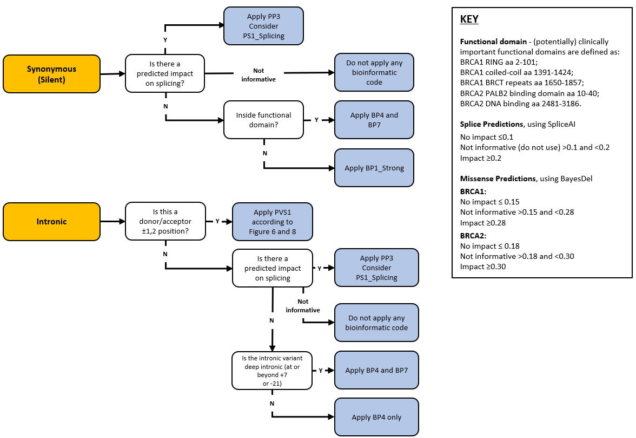
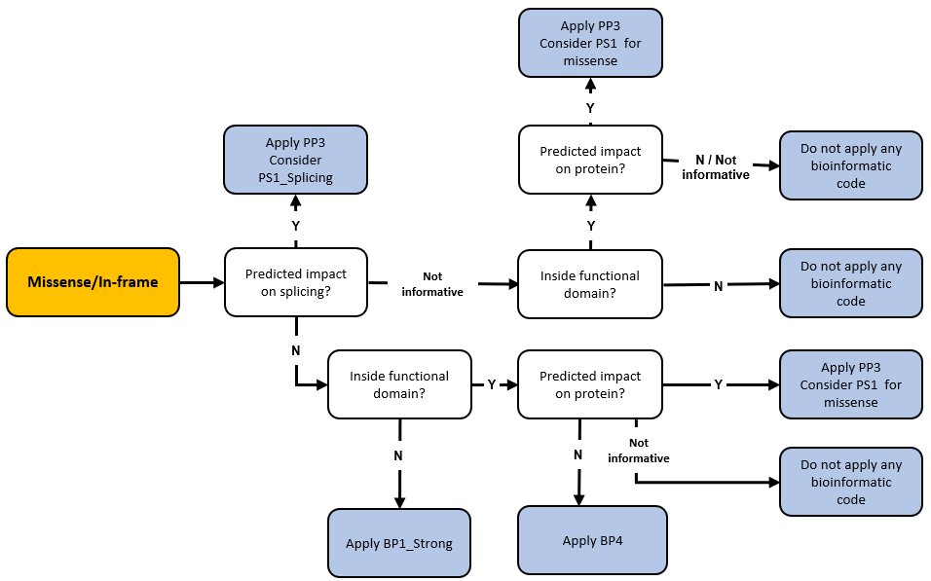

Figure 1B: Application of codes based on mRNA assay data.

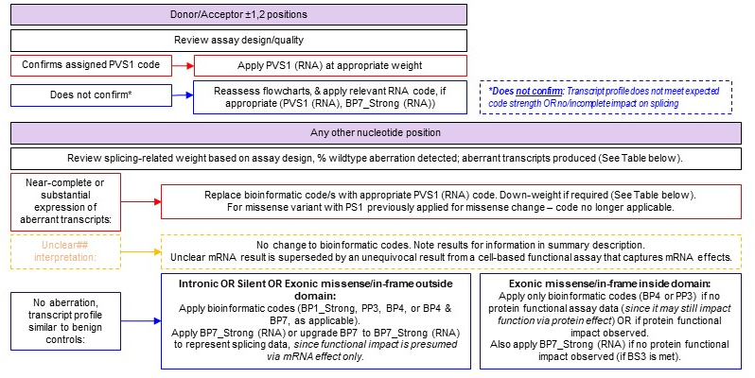
Figure 1B: Application of codes based on mRNA data (cont.). 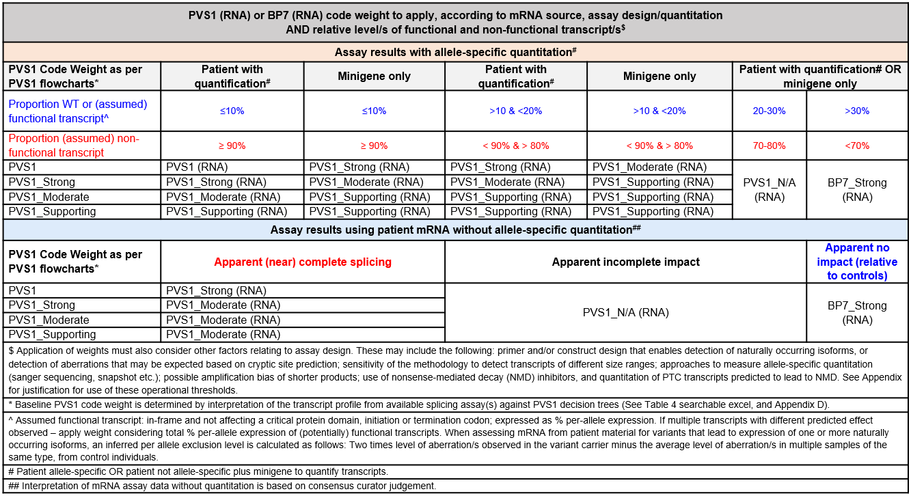

Figure 1C: Application of codes based on functional assay data, and variant type and location.


