PS2 & PM6:

Proband counting: Please refer to PP4 document for diagnostic criteria

Phenotypic consistency | Points per Proband
Phenotypic consistency | de novo with confirmed parental relationships | de novo with unconfirmed parental relationships
“Definite” diagnosis of Alexander Disease per VCEP criteria | 6 | 4
“Probable” diagnosis of Alexander Disease per VCEP criteria | 4 | 3
“Consistent” diagnosis of Alexander Disease per VCEP criteria | 3 | 1.5
Phenotype not consistent with gene | 0 | 0

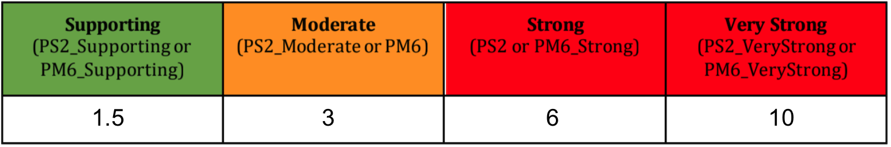

Citations
- Yoshida et al 2017 PIMD: 23903069
- Prust et al 2011 PIMD: 21917775, Li 2005 PIMD:15732097
- Unpublished GLIA-CTN biorepository data
- Test variants from these following publications were used to test the point system:
  - Li 2005 (infantile, late onset) PIMD:15732097
  - Prust 2011 (185 reported) PIMD: 21917775

